DATA MINING

Section 1 — Introduction to Data Mining

1.1 Definition of Data Mining
Data mining is a process that uses statistical, mathematical, and artificial intelligence techniques to extract and identify useful information and patterns from large sets of data.
These patterns can take the form of business rules, affinities, correlations, trends, or prediction models.

Why Is the Term a Misnomer?
The term 'data mining' is considered a misnomer. When gold is mined from rock, we call it 'gold mining' — not 'rock mining.' Similarly, data mining extracts knowledge from data, so it should have been called 'knowledge mining.'
Despite this mismatch, 'data mining' has become the accepted industry term.

Alternative Names for Data Mining
- Knowledge Extraction
- Pattern Analysis
- Data Archaeology
- Information Harvesting
- Pattern Searching
- Data Dredging

1.2 Technical Description
Data mining uses three types of techniques:
- Statistical techniques — to find patterns and relationships in data
- Mathematical techniques — to model and quantify relationships
- Artificial Intelligence (AI) techniques — to learn from data and make predictions
The patterns extracted by data mining include:
- Business rules — if-then rules about business behavior
- Affinities — items or events that occur together
- Correlations — statistical relationships between variables
- Trends — patterns that change over time
- Prediction models — models that forecast future outcomes

1.3 Characteristics and Objectives of Data Mining
- Large Databases: Data is buried deep in very large databases, sometimes spanning years. Data is often cleansed and consolidated into a data warehouse.
- Architecture: The environment is usually a client/server or web-based information system architecture.
- Visualization Tools: Sophisticated tools, including advanced visualization tools, help uncover buried information in corporate or public records.
- End-User Empowerment: End users can ask ad hoc questions and get answers quickly using data drills and query tools — with little or no programming skill.
- Parallel Processing: Large search efforts sometimes require parallel processing to handle the volume of data.
- Software Integration: Data mining tools integrate readily with spreadsheets and other software development tools.

1.4 Four Major Types of Patterns in Data Mining
- Associations — Find items or events that commonly occur together. Example: In market-basket analysis, beer and diapers are frequently purchased together.
- Predictions — Forecast future outcomes based on past events. Example: Predicting the winner of the Super Bowl, or forecasting the temperature of a specific day.
- Clusters — Identify natural groupings based on characteristics. Example: Assigning customers to different segments based on demographics and past purchase behaviors.
- Sequential Relationships — Discover time-ordered events. Example: A banking customer with a checking account will open a savings account, then an investment account within a year.

Comparison Table — Four Pattern Types:
Pattern Type | Description | Learning Type | Real-World Example
Associations | Items/events that co-occur frequently | Unsupervised | Beer & diapers in market-basket analysis
Predictions | Forecasting future events from past data | Supervised | Predicting Super Bowl winner or weather temperature
Clusters | Natural groupings based on shared characteristics | Unsupervised | Customer segmentation by demographics
Sequential Relationships | Time-ordered events and progressions | Unsupervised | Banking customer: checking → savings → investment account

Section 2 — Data Mining Task Classification

2.1 Three Main Categories of Data Mining Tasks

Prediction
Prediction uses historical data to forecast future outcomes. It answers 'what will happen next?' The output can be a class label (classification) or a numeric value (regression).

Association
Association finds rules about items or events that co-occur. It answers 'what goes together?' Example: products bought together in one transaction.

Clustering
Clustering groups similar objects without predefined labels. It answers 'what natural groups exist?' Example: grouping customers by purchasing behavior.

2.2 Supervised vs. Unsupervised Learning
Comparison Table — Supervised vs. Unsupervised Learning:
Feature | Supervised Learning | Unsupervised Learning
Training Data | Contains input variables AND class labels (output) | Contains only input variables — no output labels
Output Variable | Present and known during training | Absent — algorithm discovers structure
Example Methods | Classification, Regression | Clustering, Association
Use Case | Predicting a known outcome (e.g., spam/not spam) | Discovering hidden patterns (e.g., customer segments)
Control Mechanism | Supervised by the class label during learning | No supervising mechanism — uses heuristics

Supervised Learning: The algorithm learns from labeled training data. Both input variables (descriptive attributes) and output variables (class attributes) are provided. The model learns the mapping from input to output.
Unsupervised Learning: The algorithm receives only input variables. It discovers patterns, groupings, or structure on its own — without a supervising output variable.

2.3 Taxonomy of Data Mining Tasks, Methods, and Algorithms
Data mining is organized into a hierarchy of three levels:
- Tasks — The high-level goals: Prediction, Association, Clustering
- Methods — The approaches used to achieve each task: Classification, Regression, Clustering algorithms, Association rule mining
- Algorithms — The specific implementations: Decision Trees, Neural Networks, K-Means, Apriori, etc.
A task can be achieved using multiple methods. Each method can be implemented by multiple algorithms.

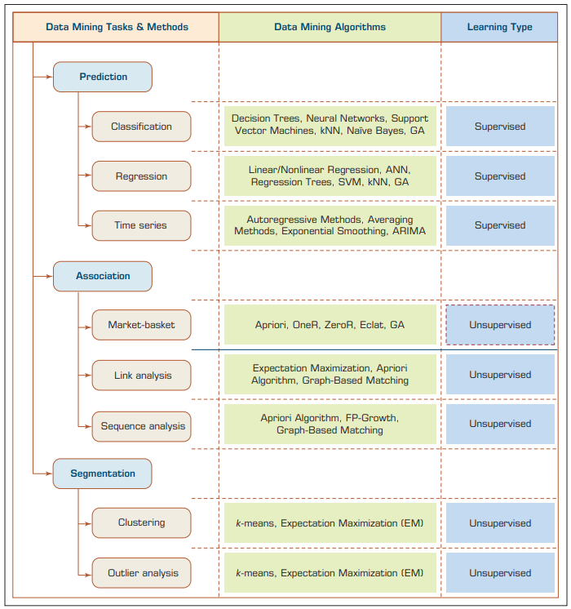

Section 3 — Data Mining Applications

3.1 Industry-Wise Applications
Data mining is applied across virtually every industry. The table below summarizes major application areas and their use cases.

Industry / Domain | Data Mining Application
Customer Relationship Management (CRM) | Identify valuable customers, predict churn, personalize marketing campaigns
Banking | Credit scoring, fraud detection, loan default prediction, customer segmentation
Retailing and Logistics | Market-basket analysis, inventory management, demand forecasting, store layout optimization
Manufacturing and Production | Quality control, predictive maintenance, defect detection, production scheduling
Brokerage and Securities Trading | Stock price prediction, algorithmic trading, portfolio risk analysis
Insurance | Fraud detection, risk assessment, policy pricing, claims processing optimization
Computer Hardware and Software | Fault prediction, usage pattern analysis, software bug detection
Government and Defense | Crime pattern analysis, national security threat detection, resource allocation
Travel Industry (Airlines, Hotels, Rental Cars) | Yield management, customer loyalty analysis, demand prediction, pricing optimization
Healthcare | Patient risk stratification, hospital readmission prediction, resource planning
Medicine | Disease diagnosis, drug discovery, clinical trial analysis, comorbidity investigation
Entertainment Industry | Content recommendation (Netflix, Spotify), audience preference analysis
Sports | Player performance analysis, game strategy optimization, injury prediction

Section 4 — The Data Mining Process (CRISP-DM)
CRISP-DM stands for Cross-Industry Standard Process for Data Mining. It is the most widely used methodology for data mining projects. It provides a structured, repeatable process with six steps.

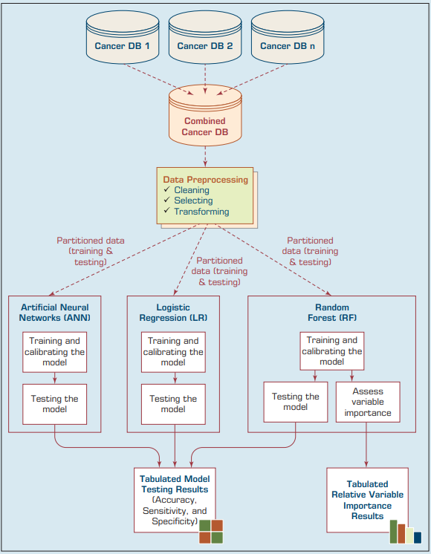

Step 1: Business Understanding
Definition: The process of understanding the business need and defining the objectives of the data mining study.
Core Concept: This is the most critical step. All subsequent steps depend on a clear business objective. Without it, the project has no direction.
Key activities:
- Identify the managerial need for new knowledge
- Write an explicit specification of the business objective
- Ask: What problem are we solving? What decision does this support?
Example business questions:
- "What are the common characteristics of customers we have lost to our competitors recently?"
- "What are typical profiles of our customers, and how much value does each provide?"
Exam Note: This step defines the entire direction of the project. Always covered in exams.

Step 2: Data Understanding
Definition: The process of identifying, collecting, and exploring the data relevant to the business objective.
Core Concept: Different business tasks require different data. The analyst must understand both the data sources and the variables.
Key considerations:
- Location: Where is the data stored and in what form?
- Collection process: Is data collection automated or manual?
- Collectors: Who collects the data and how often is it updated?
- Synonymous variables: Are there variables with the same meaning but different names?
- Homonymous variables: Are there variables with the same name but different meanings?
- Variable independence: Do variables overlap or conflict with each other?
Example: A retail project may use demographics, credit card transactions, and socioeconomic attributes to identify spending behaviors of female shoppers who purchase seasonal clothing.

Step 3: Data Preparation (Data Preprocessing)
Definition: The process of transforming raw data into a clean, analysis-ready dataset.
Core Concept: Real-world data is rarely perfect. It must be cleaned, transformed, and structured before analysis.
Time Commitment: Data preparation consumes approximately 80% of total project time.
Three key problems with real-world data:
Data Quality Problem | Definition | Example
Incomplete Data | Missing attribute values, missing attributes, or only aggregate data is available | A customer record with no age or income field
Noisy Data | Data containing errors, outliers, or incorrect values | A transaction record showing a purchase amount of -$500
Inconsistent Data | Discrepancies in codes, names, or formats across records | One table uses 'M/F', another uses 'Male/Female' for gender

Exam Note: Data Preparation is the most time-consuming step in CRISP-DM — always appears in exams.

Step 4: Model Building
Definition: The process of selecting and applying data mining techniques to the prepared dataset.
Core Concept: No single algorithm is universally best for all problems. Multiple models must be built and compared.
Key activities:
- Select candidate modeling techniques appropriate for the business task
- Apply multiple techniques and compare their results
- Use a well-defined experimentation and assessment strategy
- Identify the best-performing model for the given purpose
Exam Note: Model selection depends on the business objective — there is no single best algorithm.

Step 5: Testing and Evaluation
Definition: The process of assessing the developed models for accuracy, quality, and relevance to business objectives.
Core Concept: A model must be evaluated against both technical metrics and business requirements.
Key activities:
- Assess whether the model meets the business objectives
- Measure the degree to which it succeeds
- Decide if additional models need to be developed
- Test models in real-world scenarios when time and budget allow

Step 6: Deployment
Definition: The process of organizing and presenting the discovered knowledge so end users can understand and use it.
Core Concept: Data mining does not end at model building. The knowledge gained must be delivered to the people who need it.
Key activities:
- Organize and present knowledge in a user-understandable format
- Integrate the model into existing business processes or systems
- Maintain the deployed model — because business data changes constantly
- Update models when the underlying data patterns shift
Exam Note: Deployment includes both presentation of knowledge AND ongoing maintenance of models.

CRISP-DM Summary Table:
Step No. | Step Name | Key Activity | Primary Output
1 | Business Understanding | Define business objectives and project goals | Project plan and objective statement
2 | Data Understanding | Identify, collect, and explore relevant data | Data inventory and exploration report
3 | Data Preparation | Clean, transform, and prepare data (80% of time) | Clean, analysis-ready dataset
4 | Model Building | Select and apply modeling techniques | Multiple trained candidate models
5 | Testing and Evaluation | Assess model accuracy and business fit | Evaluated and selected model
6 | Deployment | Present and maintain knowledge for end users | Deployed solution with maintenance plan

Section 5 — Other Data Mining Processes and Methodologies

5.1 SEMMA Process
SEMMA was developed by SAS Institute. It is a data mining process methodology tied to the SAS software environment.
SEMMA stands for:
Letter | Phase | Description
S | Sample | Select a representative sample of the data to work with
E | Explore | Visualize and explore the data to identify patterns and anomalies
M | Modify | Create, select, and transform variables for modeling
M | Model | Apply modeling techniques to the modified data
A | Assess | Evaluate the usefulness and reliability of the model

Exam Note: SEMMA is tool-specific (SAS), while CRISP-DM is tool-independent and industry-neutral.

5.2 KDD — Knowledge Discovery in Databases
KDD stands for Knowledge Discovery in Databases.
Definition (Fayyad et al., 1996): KDD is the process of using data mining methods to find useful information and patterns in data. It is a comprehensive process that encompasses data mining as one of its steps.

KDD vs. Data Mining: Key Distinction
- KDD: A comprehensive, end-to-end process for discovering knowledge from organizational data
- Data Mining: The specific algorithmic step within KDD where patterns are extracted from data
In other words, data mining is one step inside the larger KDD process.
Role of the Enterprise Data Warehouse: The enterprise data warehouse enables KDD to be implemented efficiently. It provides a single, integrated source of organizational data to be mined.

Five Steps of KDD (Dunham, 2003)
- Data Selection — Choose the relevant subset of data
- Data Preprocessing — Clean and prepare the selected data
- Data Transformation — Convert data into a suitable format for mining
- Data Mining — Apply algorithms to extract patterns
- Interpretation / Evaluation — Interpret patterns and evaluate usefulness

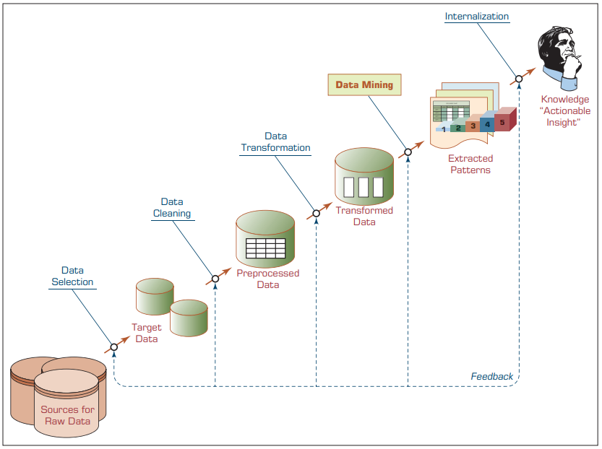
Comparison Table — CRISP-DM vs. SEMMA vs. KDD:
Feature | CRISP-DM | SEMMA | KDD
Number of Steps | 6 | 5 | 5
Developed By | Consortium (DaimlerChrysler, SPSS, NCR, etc.) | SAS Institute | Fayyad et al. (1996)
Tool Dependency | Tool-independent | SAS-specific | Tool-independent
Scope | Full project lifecycle from business need to deployment | Data-centric — focuses on modeling process | Full knowledge discovery process
Primary Focus | Business understanding and deployment | Modeling and assessment | Knowledge extraction from databases

Section 6 — Data Mining Methods
Four main data mining methods are used in practice. Most software tools implement more than one method.

6.1 Classification
Definition: Classification is a supervised learning method that learns patterns from labeled historical data and assigns new instances to predefined classes.
Core Concept: The algorithm learns from past data where the class label is known. It then uses that knowledge to predict the class of new, unlabeled data.

How It Works
- Collect training data with known class labels
- Train the classification model on the training data
- Evaluate the model on a holdout test set
- Deploy the model to classify new, unknown instances

Examples of Classification Tasks
- Credit approval — Good credit risk / Bad credit risk
- Weather prediction — Sunny / Rainy / Cloudy
- Fraud detection — Yes / No
- Store location selection — Good / Moderate / Bad
- Customer churn — Likely to leave / Not likely to leave

Classification vs. Regression — Critical Distinction
Classification: Output is a class label (a category). Example: predicting weather as 'sunny', 'rainy', or 'cloudy'.
Regression: Output is a numeric value. Example: predicting the exact temperature as 68°F.
Exam Note: If output = class label → Classification. If output = number → Regression. This distinction is frequently tested.

6.2 Regression
Definition: Regression is a supervised learning method that predicts a continuous numeric output value.
Core Concept: Regression models the relationship between input variables and a continuous output. It is used when the prediction target is a number, not a category.
Example: Predicting the temperature of a specific day (e.g., 68°F) based on historical weather data.

6.3 Clustering
Definition: Clustering is an unsupervised learning method that discovers natural groupings of objects based on their similarity.
Core Concept: No class labels are provided. The algorithm uses heuristics — such as multidimensional distance measures — to group similar objects together.
Example: Assigning customers to different segments based on their demographics and past purchase behaviors.

Key Difference: Clustering vs. Classification
- Classification: Supervised — the class labels are known during training
- Clustering: Unsupervised — no class labels; groups are discovered automatically
- Classification: Has a controlling mechanism (the class label)
- Clustering: No controlling mechanism — uses heuristics like distance measures

6.4 Association
Definition: Association is a data mining method that finds rules about items or events that frequently co-occur.
Core Concept: Association rule mining identifies if-then relationships between items. It is the method behind market-basket analysis.
Example: Customers who buy beer also frequently buy diapers. Rule: 'beer → diapers' with high confidence.

Comprehensive Comparison Table — Four Data Mining Methods:
Feature | Classification | Regression | Clustering | Association
Learning Type | Supervised | Supervised | Unsupervised | Unsupervised
Output Type | Class label (category) | Numeric value | Group/cluster membership | If-then rules
Class Labels in Training | Required | Required (numeric) | Not required | Not required
Algorithm Type | Decision Trees, Neural Nets, SVM | Linear/Logistic Regression | K-Means, DBSCAN | Apriori, FP-Growth
Real-World Example | Fraud detection (yes/no) | Temperature prediction (68°F) | Customer segmentation | Market-basket analysis

Section 7 — Classification in Depth: Model Assessment

7.1 The Two-Step Classification Methodology
Every classification process follows two main phases:

Phase 1: Model Development (Training)
- A collection of training data is used — including both input variables and known class labels
- The algorithm learns the mapping from input variables to class labels
- The output of this phase is a trained classification model

Phase 2: Model Testing and Deployment
- The trained model is tested against a holdout sample (test dataset not used in training)
- Accuracy is assessed by comparing predicted labels vs. actual labels
- If accuracy is satisfactory, the model is deployed to classify new, unknown instances

7.2 Five Factors for Assessing Classification Models
When evaluating a classification model, five key factors are considered:

1. Predictive Accuracy
Definition: The model's ability to correctly predict the class label of new or previously unseen data.
Predictive accuracy is the most commonly used assessment factor.
How to compute:
- Take a test dataset with known class labels
- Run the model to predict class labels for each record
- Compare predicted labels to actual labels
Accuracy Rate = (Correctly Classified Instances / Total Instances) × 100%
Variable definitions:
- Correctly Classified Instances: Number of test records where the model's prediction matched the actual class label
- Total Instances: Total number of records in the test dataset

2. Speed
Definition: The computational cost involved in generating and using the model.
Faster models are preferred. Speed matters both during training and during prediction.

3. Robustness
Definition: The model's ability to make reasonably accurate predictions even when given noisy data, data with missing values, or data with errors.
A robust model maintains performance despite imperfect input data.

4. Scalability
Definition: The ability to construct a prediction model efficiently when given very large amounts of data.
A scalable model can handle growing datasets without a significant drop in performance or unacceptable increases in computation time.

5. Interpretability
Definition: The level of understanding and insight provided by the model — how and why the model makes certain predictions.
High interpretability means stakeholders can understand and trust the model's decisions.

Summary Table — Model Assessment Factors:
Factor | Definition | Why It Matters
Predictive Accuracy | % of correct predictions on unseen data | Primary measure of model quality
Speed | Computational cost of training and prediction | Affects real-time usability in production
Robustness | Accuracy maintained despite noisy/missing data | Real-world data is always imperfect
Scalability | Efficiency with very large datasets | Enterprise data can be massive
Interpretability | Understandability of model decisions | Builds stakeholder trust and regulatory compliance

7.3 The Confusion Matrix
Definition: A confusion matrix (also called a classification matrix or contingency table) is a table that summarizes the performance of a classification model.
It is the primary source for accuracy estimation in classification problems.

Structure for a Two-Class Problem
The rows represent the actual class. The columns represent the predicted class.
 | Predicted: POSITIVE | Predicted: NEGATIVE
Actual: POSITIVE | True Positive (TP) | False Negative (FN)
Actual: NEGATIVE | False Positive (FP) | True Negative (TN)

Explanation of Each Cell
- True Positive (TP): The model predicted POSITIVE and the actual label is POSITIVE. Correct prediction.
- True Negative (TN): The model predicted NEGATIVE and the actual label is NEGATIVE. Correct prediction.
- False Positive (FP): The model predicted POSITIVE but the actual label is NEGATIVE. Incorrect — also called Type I Error.
- False Negative (FN): The model predicted NEGATIVE but the actual label is POSITIVE. Incorrect — also called Type II Error.

Key Formulas Derived from the Confusion Matrix
Metric | Formula | Intuition | Practical Meaning
Accuracy | (TP + TN) / (TP+TN+FP+FN) | Overall correct predictions / all predictions | What % of all predictions were correct?
Precision | TP / (TP + FP) | Correct positive predictions / all predicted positives | When the model says positive, how often is it right?
Recall (Sensitivity) | TP / (TP + FN) | Correct positive predictions / all actual positives | Of all actual positives, how many did we catch?
Specificity | TN / (TN + FP) | Correct negative predictions / all actual negatives | Of all actual negatives, how many did we correctly reject?
F1 Score | 2 × (Precision × Recall) / (Precision + Recall) | Harmonic mean of Precision and Recall | Balances precision and recall — useful for imbalanced datasets

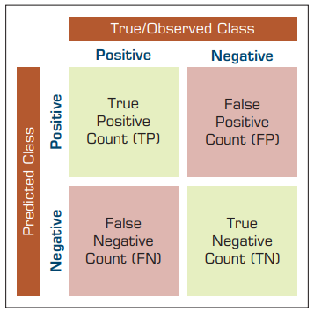

Section 8 — Exam Preparation

8.1 Quick Revision Notes

Section 1 — Introduction
- Data mining extracts knowledge from large datasets using statistical, mathematical, and AI techniques.
- 'Data mining' is a misnomer — knowledge mining would be more accurate.
- Alternative names: knowledge extraction, pattern analysis, data archaeology, information harvesting.
- Four pattern types: Associations, Predictions, Clusters, Sequential Relationships.

Section 2 — Task Classification
- Three main tasks: Prediction, Association, Clustering.
- Supervised learning uses labeled data (input + output). Unsupervised uses only input.
- Classification and regression are supervised; clustering and association are unsupervised.

Section 3 — Applications
- Data mining is applied in 13+ industries including banking, healthcare, retail, sports, and government.

Section 4 — CRISP-DM
- CRISP-DM has 6 steps: Business Understanding, Data Understanding, Data Preparation, Model Building, Testing & Evaluation, Deployment.
- Step 3 (Data Preparation) consumes ~80% of total project time.
- Data problems: Incomplete, Noisy, Inconsistent.

Section 5 — SEMMA and KDD
- SEMMA: Sample → Explore → Modify → Model → Assess. Developed by SAS Institute. Tool-specific.
- KDD: Selection → Preprocessing → Transformation → Mining → Interpretation. Tool-independent.
- Data mining is ONE step inside the broader KDD process.

Section 6 — Methods
- Classification = supervised, outputs class label.
- Regression = supervised, outputs numeric value.
- Clustering = unsupervised, discovers natural groups.
- Association = unsupervised, finds co-occurring items.

Section 7 — Model Assessment
- Five assessment factors: Predictive Accuracy, Speed, Robustness, Scalability, Interpretability.
- Confusion matrix shows TP, TN, FP, FN for a two-class problem.
- Key formulas: Accuracy, Precision, Recall, Specificity, F1 Score.

8.2 Important Definitions (Glossary)
Term | Definition
Data Mining | A process using statistical, mathematical, and AI techniques to extract useful patterns and knowledge from large datasets
Knowledge Discovery in Databases (KDD) | A comprehensive end-to-end process for discovering useful knowledge from organizational data; data mining is one step within it
CRISP-DM | Cross-Industry Standard Process for Data Mining; a 6-step industry-standard methodology for executing data mining projects
SEMMA | Sample, Explore, Modify, Model, Assess; a 5-step data mining process developed by SAS Institute
Classification | A supervised data mining method that learns from labeled data to assign class labels to new instances
Regression | A supervised method that predicts a continuous numeric output variable
Clustering | An unsupervised method that discovers natural groupings in data without predefined class labels
Association | An unsupervised method that finds rules about items or events that frequently co-occur
Supervised Learning | Learning from labeled training data that includes both input variables and the output class label
Unsupervised Learning | Learning from data that includes only input variables; the algorithm discovers structure independently
Training Data | The labeled dataset used to train a classification or regression model
Holdout Sample | A test dataset not used in training, reserved for evaluating model accuracy
Confusion Matrix | A table summarizing classification performance showing TP, TN, FP, FN counts
True Positive (TP) | A prediction where the model correctly predicted the positive class
False Positive (FP) | A prediction where the model incorrectly predicted positive when the actual label was negative (Type I Error)
Predictive Accuracy | The percentage of test instances correctly classified by the model
Robustness | The model's ability to maintain accuracy despite noisy, missing, or erroneous input data
Scalability | The model's ability to perform efficiently when applied to very large datasets
Interpretability | The degree to which the model's decision process can be understood by humans
Data Preprocessing | The transformation of raw data into a clean, analysis-ready dataset (Step 3 of CRISP-DM)
Data Warehouse | A centralized integrated repository of organizational data used as the input for data mining and KDD
Market-Basket Analysis | A data mining application that finds associations between products purchased together in the same transaction
Pattern | A recurring regularity or rule discovered in data by a data mining algorithm
Prediction | Forecasting the value of a variable (class label or numeric) based on historical patterns
Heuristic | A problem-solving approach that uses practical rules or distance measures to find approximate solutions, used in clustering

8.3 Important Formulas

Accuracy Rate (Basic)
Accuracy Rate = (Correctly Classified Instances / Total Instances) × 100%
Variables: Correctly Classified Instances = number of test records where prediction matched actual label; Total Instances = total test records.
Intuition: What percentage of all predictions were correct?

Confusion Matrix Formulas
Accuracy = (TP + TN) / (TP + TN + FP + FN)
All correct predictions divided by all predictions. Best general performance measure.

Precision = TP / (TP + FP)
Of all predicted positives, how many were actually positive? High precision = few false alarms.

Recall (Sensitivity) = TP / (TP + FN)
Of all actual positives, how many did the model catch? High recall = few missed positives.

Specificity = TN / (TN + FP)
Of all actual negatives, how many did the model correctly reject? High specificity = few false positives.

F1 Score = 2 × (Precision × Recall) / (Precision + Recall)
Harmonic mean of Precision and Recall. Useful when the dataset is imbalanced (one class is much more frequent than the other).

8.4 Important Comparisons

Data Mining vs. KDD
Feature | Data Mining | KDD
Definition | Algorithmic step that extracts patterns from data | Comprehensive process for knowledge discovery
Scope | Narrow — one step in a process | Broad — encompasses data mining
Steps | Applies algorithms to find patterns | Selection, Preprocessing, Transformation, Mining, Interpretation
Focus | Pattern extraction | End-to-end knowledge discovery

Classification vs. Regression
Feature | Classification | Regression
Output Type | Class label (category) | Numeric value
Learning Type | Supervised | Supervised
Example | Weather: sunny/rainy/cloudy | Temperature: 68°F
Common Algorithms | Decision Trees, Neural Nets, SVM | Linear Regression, Logistic Regression

Classification vs. Clustering
Feature | Classification | Clustering
Learning Type | Supervised | Unsupervised
Class Labels in Training | Required | Not required
Control Mechanism | Class label supervises learning | Heuristics (e.g., distance measures)
Output | Predicts known class labels | Discovers new groups/clusters
Example | Spam detection (spam/not spam) | Customer segmentation

Supervised vs. Unsupervised Learning
Feature | Supervised Learning | Unsupervised Learning
Training Data | Input + Output (labeled) | Input only (unlabeled)
Output Variable | Present and known | Absent
Example Methods | Classification, Regression | Clustering, Association
Goal | Predict a known output | Discover hidden structure
Control | Supervised by class labels | No external supervision

CRISP-DM vs. SEMMA vs. KDD
Feature | CRISP-DM | SEMMA | KDD
Steps | 6 | 5 | 5
Developed By | Industry consortium | SAS Institute | Fayyad et al. (1996)
Tool Dependency | Independent | SAS-specific | Independent
Business Orientation | Strong (Step 1 = Business Understanding) | Weak | Moderate
Includes Deployment | Yes | No | No (ends at interpretation)

8.5 Frequently Asked Exam Questions

Q1. Q: What is data mining? Why is it considered a misnomer?
A: Data mining is a process that uses statistical, mathematical, and AI techniques to extract useful patterns and knowledge from large datasets. It is called a misnomer because, just as gold mining extracts gold (not rock), data mining extracts knowledge (not data). It should more accurately be called 'knowledge mining.'

Q2. Q: What are the four major types of patterns identified by data mining?
A: The four types are: (1) Associations — items that co-occur (e.g., beer and diapers); (2) Predictions — forecasting future events from past data; (3) Clusters — natural groupings of similar objects; (4) Sequential Relationships — time-ordered event progressions.

Q3. Q: What is the most time-consuming step in CRISP-DM and why?
A: Step 3: Data Preparation. It consumes approximately 80% of the total project time because real-world data is incomplete (missing values), noisy (errors, outliers), and inconsistent (discrepancies in codes or names).

Q4. Q: What is the difference between classification and regression?
A: Both are supervised learning methods. Classification predicts a class label (a category), such as 'sunny' or 'rainy.' Regression predicts a numeric value, such as a temperature of 68°F.

Q5. Q: What is the difference between classification and clustering?
A: Classification is supervised — it uses labeled training data with known class labels to predict labels for new data. Clustering is unsupervised — it has no class labels and discovers natural groupings on its own using heuristics like distance measures.

Q6. Q: What is a confusion matrix and what does it measure?
A: A confusion matrix is a table that summarizes the performance of a classification model. It shows the counts of True Positives (TP), True Negatives (TN), False Positives (FP), and False Negatives (FN). It is the primary source for accuracy estimation in classification.

Q7. Q: What does SEMMA stand for?
A: S — Sample, E — Explore, M — Modify, M — Model, A — Assess. SEMMA was developed by SAS Institute.

Q8. Q: What is KDD and how does it differ from data mining?
A: KDD (Knowledge Discovery in Databases) is a comprehensive end-to-end process for discovering knowledge from data. Data mining is just one step within KDD — the algorithmic step where patterns are extracted. KDD also includes data selection, preprocessing, transformation, and interpretation.

Q9. Q: What are the five factors for assessing a classification model?
A: The five factors are: (1) Predictive Accuracy, (2) Speed, (3) Robustness, (4) Scalability, and (5) Interpretability.

Q10. Q: What formula is used to compute accuracy rate?
A: Accuracy Rate = (Correctly Classified Instances / Total Instances) × 100%. Correctly Classified Instances is the count of test records where the predicted label matched the actual label. Total Instances is the total number of test records.

Q11. Q: What is supervised learning?
A: Supervised learning is a machine learning approach where the training data includes both the input variables (descriptive attributes) and the output variable (class label). The algorithm learns the mapping from input to output using these labeled examples.

Q12. Q: What is market-basket analysis?
A: Market-basket analysis is a data mining application that finds associations between products purchased together in the same transaction. A classic example is the association between beer and diapers being purchased together.

Q13. Q: What is the role of the enterprise data warehouse in KDD?
A: The enterprise data warehouse serves as a single, integrated source of organizational data. It enables KDD to be implemented efficiently because all relevant data can be accessed from one central location rather than scattered across multiple systems.

Q14. Q: What is parallel processing and when is it used in data mining?
A: Parallel processing uses multiple processors simultaneously to perform computations. In data mining, it is used when datasets are very large and the search effort is massive — where a single processor would be too slow to complete the analysis in a reasonable time.

Q15. Q: What is the deployment step in CRISP-DM?
A: Deployment is the final step in CRISP-DM. It involves organizing and presenting the discovered knowledge so end users can understand and benefit from it. It also includes maintaining the deployed models, as business data constantly changes and models may need to be updated.

8.6 Viva Questions with Answers

V1. Q: Explain the CRISP-DM process with a real-world example.
Detailed Answer: CRISP-DM has 6 steps. Using a bank fraud detection project as an example: (1) Business Understanding — the bank wants to detect fraudulent transactions; (2) Data Understanding — collect transaction history, customer data, and account activity; (3) Data Preparation — clean missing values and encode categorical variables; (4) Model Building — train a classification model (e.g., Decision Tree); (5) Testing and Evaluation — test accuracy using a holdout set and confusion matrix; (6) Deployment — integrate the model into the bank's transaction processing system and monitor it for performance degradation.

V2. Q: Why does data preprocessing consume 80% of a data mining project's time?
Detailed Answer: Real-world data is almost never clean or ready for analysis. Three fundamental problems must be solved: (1) Incomplete data — records with missing fields must be handled (imputed or removed); (2) Noisy data — outliers and errors must be detected and corrected; (3) Inconsistent data — naming conventions, codes, and formats must be standardized. Each problem requires careful, labor-intensive investigation and manual or semi-automated correction across potentially millions of records.

V3. Q: How do you evaluate a classification model?
Detailed Answer: Use the confusion matrix to compute: Accuracy (overall correctness), Precision (correctness among positive predictions), Recall (coverage of actual positives), and F1 Score (balance of Precision and Recall). Also evaluate Speed (how fast does it predict?), Robustness (does it handle noisy data?), Scalability (can it handle large datasets?), and Interpretability (can users understand why it made its decisions?).

V4. Q: What is the difference between supervised and unsupervised learning?
Detailed Answer: Supervised learning uses labeled training data — both input variables and the output class label are provided. The algorithm learns a function from input to output. Unsupervised learning uses only input variables — no labels are provided. The algorithm discovers patterns or groupings on its own using heuristics. Classification and regression are supervised; clustering and association are unsupervised.

V5. Q: Explain the confusion matrix with an example.
Detailed Answer: Suppose we build a model to detect email spam (Positive = Spam, Negative = Not Spam). We test on 100 emails: 40 are spam, 60 are not. The model predicts: TP=35 (correctly identified spam), TN=55 (correctly identified non-spam), FP=5 (marked as spam but weren't), FN=5 (missed spam). Accuracy = (35+55)/100 = 90%. Precision = 35/40 = 87.5%. Recall = 35/40 = 87.5%. These numbers tell us how well the model performs for each type of error.

V6. Q: What are associations in data mining? Give an example.
Detailed Answer: Associations identify items or events that frequently occur together. The classic example is market-basket analysis: a supermarket analyzes transaction data and discovers that customers who buy beer also frequently buy diapers. This association rule (beer → diapers) can be used to optimize store layout or promotional offers.

V7. Q: What is the difference between KDD and CRISP-DM?
Detailed Answer: KDD is a conceptual framework that describes the process of knowledge discovery from databases — it is academic and theoretical. CRISP-DM is a practical, industry-standard methodology for executing data mining projects — it is operational and includes business-oriented steps like Business Understanding and Deployment. CRISP-DM has 6 steps; KDD has 5. Both are tool-independent.

V8. Q: Why is Business Understanding considered the most important step in CRISP-DM?
Detailed Answer: Without a clear business objective, all subsequent steps are misdirected. The data collected, the preprocessing applied, the model built, and the deployment strategy all depend on what problem the project is solving. A model that is technically excellent but answers the wrong business question has zero value. Business Understanding anchors the entire project.

V9. Q: What is the taxonomy of data mining? Explain its three levels.
Detailed Answer: The taxonomy organizes data mining into three levels: (1) Tasks — the high-level goals (Prediction, Association, Clustering); (2) Methods — the approaches for achieving each task (Classification, Regression, K-Means, Apriori, etc.); (3) Algorithms — specific implementations of each method (Decision Trees, Neural Networks, SVM, K-Means, Apriori). One task can have multiple methods; one method can be implemented by multiple algorithms.

V10. Q: What makes a data mining model robust and why does it matter?
Detailed Answer: A robust model maintains reasonable accuracy even when given noisy data, missing values, or erroneous input. This matters because real-world production data is always imperfect. A model that performs well only on clean test data but fails in production due to data quality issues is not usable. Robustness is tested by deliberately introducing noise into the test dataset and measuring accuracy degradation.

8.7 One-Page Revision Summary
Data Mining: A process using statistical, mathematical, and AI techniques to extract useful patterns and knowledge from large datasets.

4 Pattern Types
- Associations: Items that co-occur (e.g., beer & diapers)
- Predictions: Forecasting future outcomes from past data
- Clusters: Natural groupings based on similarity
- Sequential Relationships: Time-ordered event chains

3 Data Mining Task Categories
- Prediction | Association | Clustering

6 CRISP-DM Steps
- Business Understanding: Define project goals and business objectives
- Data Understanding: Identify, collect, and explore relevant data
- Data Preparation: Clean and transform data (80% of time)
- Model Building: Select and apply modeling techniques
- Testing & Evaluation: Assess accuracy and business fit
- Deployment: Present knowledge and maintain models

4 Data Mining Methods
- Classification: Supervised → outputs class label
- Regression: Supervised → outputs numeric value
- Clustering: Unsupervised → discovers natural groups
- Association: Unsupervised → finds co-occurring items

5 Model Assessment Factors
- Accuracy: % of correct predictions
- Speed: Computational efficiency
- Robustness: Handles noisy/missing data
- Scalability: Works with large datasets
- Interpretability: Model decisions are understandable

Confusion Matrix Formulas
Accuracy = (TP+TN)/(TP+TN+FP+FN) Precision = TP/(TP+FP)
Recall = TP/(TP+FN) F1 = 2×(P×R)/(P+R)

Key Comparisons
- Classification vs. Clustering: Classification is supervised (has labels); Clustering is unsupervised (discovers groups)
- Supervised vs. Unsupervised: Supervised has output labels in training data; Unsupervised has only input data

